1. What does RGBA stand for?

RGBA stands for red green blue alpha.

2. From the Pillow module, how do you get the RGBA value of any images?

ImageColor.getcolor() gives rgba value of any image

3. What is a box tuple, and how does it work?

A box tuple is a tuple value of four integers coordinates that represent a rectangular region in an image.

The four integers are, in order, as follows:

**Left** The x-coordinate of the leftmost edge of the box.

**Top** The y-coordinate of the top edge of the box.

**Right** The x-coordinate of one pixel to the right of the rightmost edge of the box.

This integer must be greater than the left integer.

**Bottom** The y-coordinate of one pixel lower than the bottom edge of the box.

This integer must be greater than the top integer.

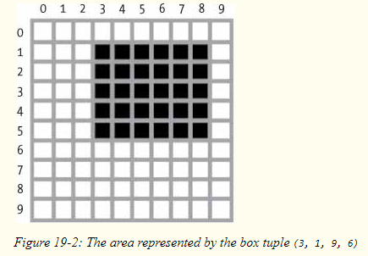

4. Use your image and load in notebook then, How can you find out the width and height of an Image object?

from PIL import Image

pic = Image.open('Pic.jpg')

print(f'Width, Height -> {pic.size}') *# Approach 1*

print(f'Width, Height -> {pic.width},{pic.height}') *# Approach 2*

width,height = pic.size

print(f'Width, Height -> {width},{height}') *# Approach 3*

5. What method would you call to get Image object for a 100×100 image, excluding the lower-left quarter of it?

from PIL import Image

img = Image.open('Pic.jpg')

new_img = img.crop((0,50,50,50))

6. After making changes to an Image object, how could you save it as an image file?

from PIL import Image

pic = Image.open('pic.jpg')

pic.save('pic2.jpg')

7. What module contains Pillow’s shape-drawing code?

Pillows ImageDraw module contains Shape drawing methods

8. Image objects do not have drawing methods. What kind of object does? How do you get this kind of object?

 ImageDraw objects have shape-drawing methods such as point(), line(), or rectangle().They are returned by passing the Image object to the ImageDraw.Draw() function.